**UNIVERSITY OF ZAMBIA**

**SCHOOL OF NATURAL SCIENCES**

**DEPARTMENT OF COMPUTER SCIENCE**

Name: Chisomo Y Banja

Student ID: 2021442012

Course Code: CSC 4631

Course: Software Maintenance

Lecturer : Mr Sinkala

1. Cloned the repository into my local directory.

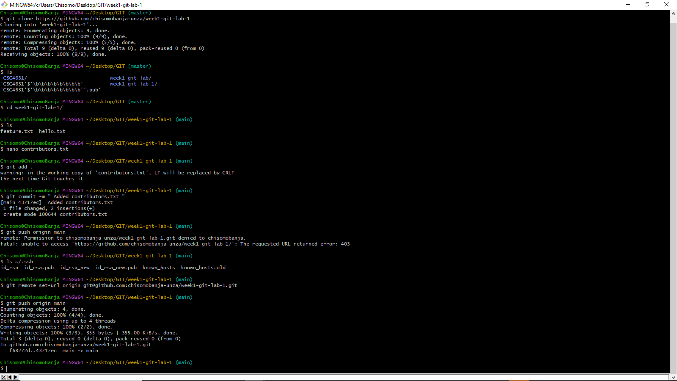

1. Created and edited the contributors.txt using the nano editor



1. Moved the edited file to the staging area



1. Used git commit to commit the changes into local repo



1. Used git push origin main to push the changes into the remote counterpart of the project in the main branch but first had to use the git remote set-url command changes an existing remote repository URL
2. Since the repo has now been uploaded to the remote repo, the rest is done from github.com. A prompt is given on the repo to update the branch to the latest version, clicking that gives a prompt to conduct a pull request. Clicking the pull request results in the following page:

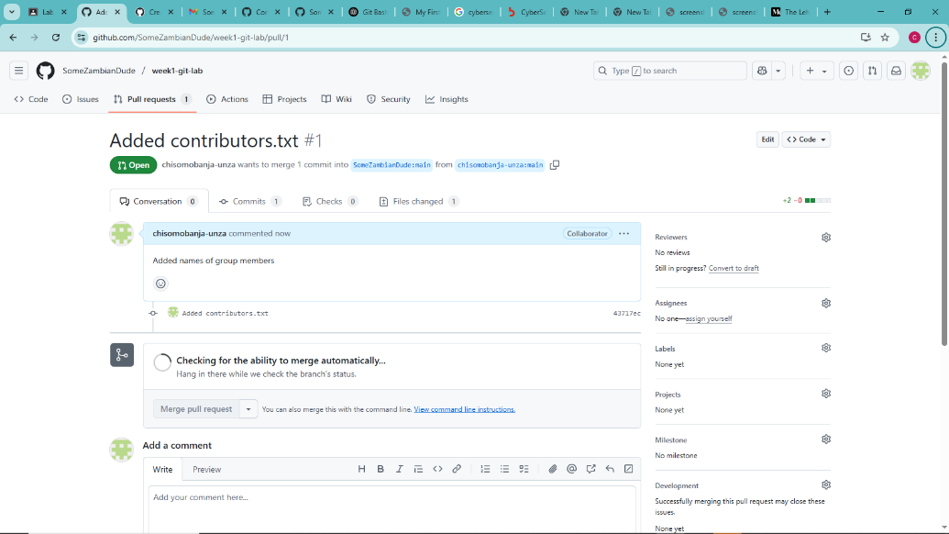

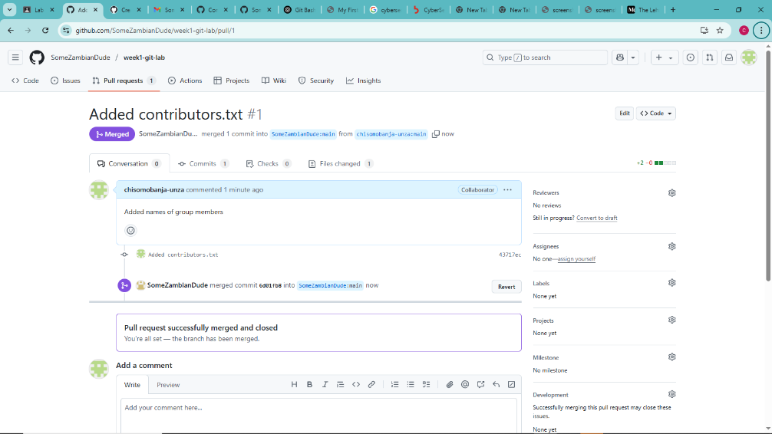

GitHub repository links:

<https://github.com/chisomobanja-unza/week1-git-lab>

Forked: <https://github.com/chisomobanja-unza/week1-git-lab-1>